Visual Immersion Project Proposal Form

Project Title: Consumed by the Canyons [WIP]
Team Members: Sam Payne

Project Overview
Brief Description: I want to ensure that I can personally go from concept to product alone, so that I can test my full capabilities as an artist of games. I want to explore different methods of 3D workflow using blender and experiment with different techniques to produce the results I am hoping for with this project. In regard to the contents, I hope to replicate a desolate, empty feeling to my environment.
Chosen theme: A – Forgotten Utopia
Scope and Deliverables: I don’t want to make the project too big, but there will be a focus in regard to, as the core location of this forgotten utopia is within a canyon/cave area, but in regards to the buildings, some will be larger as a focal point but I will also try and make sure smaller residential areas get some attention as well to make that feeling of it being a city real.

Project Plan
Timeline: TOTAL TIME 14 WEEKS
Concept – 2 weeks
Block out – 1 week
“Clean Poly” assets – 2 weeks
High poly assets – 3 weeks
Texture – 2 weeks
Lighting – 1 week
Animations – 2 weeks
Render – 1 week
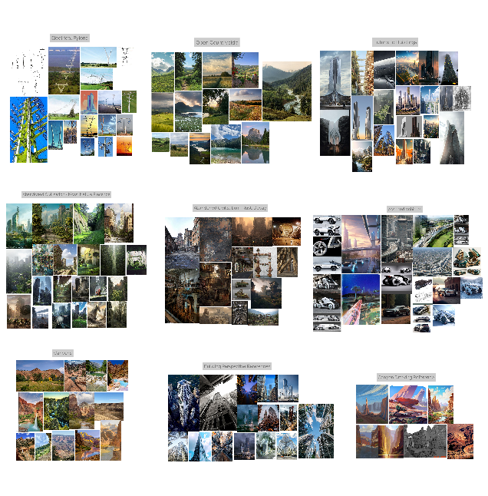
Artistic Direction:
Level Design: Focus is the travel hub in the middle of the canyon, surrounded by massive canyon walls of rock, in the environment itself will be assorted roads, broken structures (such as tunnels/tubes, may include buildings or pylons (electrical)). Hope to have waterflow or invasion of water, as well as intensely display the fact that moss and grass would have of invaded the area and overtaken it. Try to incorporate both rust and moss/green life as a cooperative rather than have one as a focus.

Project Management
Project Risks: Working alone is quite strenuous, Time management and meeting deadlines. Assuring my quality from my expectations. Other life factors (Work, People, etc)
Project Milestones: Block-out Completed, Models Completed, Textures Completed
Project Monitoring & Review: Keep my lecturers updated with progress on a bi-weekly basis to make sure I am committing to my deadlines, and if I am struggling to let them know immediately.

Project Evaluation
Success Criteria: It will be an improvement compared to the environment I had created last year, and I myself will feel proud of what I have created.
Post-Project Evaluation: Comparison as well as peer evaluation, specifically with others who picked the same project genre as me. As well as visual comparison with my other projects.

Signatures
Student / Team Leaders Signature: ___________________________ Date: ________
Tutor Signature: __________________________________________ Date: ________

